**House Rent Prediction**

**1.Team Members**

Avighyat Srivastav - E22BCAU0083

Aryan Singh Kaushik – E22BCAU0075

**2. ABSTRACT**

Accurately predicting house rent is crucial for various stakeholders in the real estate market, including landlords, tenants, investors, and policymakers. This literature survey aims to provide a comprehensive overview of various machine learning techniques employed for house rent prediction. The survey analyzes the performance of different algorithms, datasets, and evaluation metrics used in existing research. The findings suggest that ensemble methods, such as Random Forest and simple linear regression, consistently outperform other techniques in terms of predictive accuracy. Additionally, the availability f large and diverse datasets is essential for developing robust and generalizable prediction models..

**3. KEYWORDS:**

Real estate, House rent prediction, Machine learning, Ensemble methods, Random Forest, simple linear regression, Support Vector Regression (SVR) Large and diverse datasets, Evaluation metrics, R-squared, Mean Absolute Error (MAE), Model interpretability.

**4. INTRODUCTION**

The real estate market is a complex and dynamic ecosystem, with house rent being a key factor influencing decisions made by various stakeholders. Accurate rent predictions are crucial for landlords, tenants, investors, and policymakers alike. Landlords rely on accurate rent predictions to set appropriate rental rates, ensuring a fair return on their investment while maintaining tenant affordability. Tenants utilize rent predictions to estimate housing expenses, enabling them to make informed decisions about their living arrangements and financial planning. Investors employ rent predictions to assess the potential profitability of rental properties, guiding their investment decisions and risk assessments. Policymakers, on the other hand, utilize rent predictions to understand market trends, inform housing policies, and allocate resources effectively.

Traditionally, house rent prediction has been based on subjective assessments and historical data analysis. Industry experts, real estate agents, and property managers relied on their experience and knowledge of local market conditions to make rent estimates. Historical data analysis involved examining past rent trends and identifying correlations with economic indicators or property characteristics. However, these methods were often limited by the availability of reliable data, the subjectivity of expert opinions, and the inability to capture complex relationships between multiple factors.

The advent of machine learning has revolutionized the field of house rent prediction, providing powerful tools for data-driven and objective forecasting. Machine learning algorithms can analyze vast amounts of data, identify patterns, and make predictions based on these patterns. This capability has led to the development of sophisticated rent prediction models that can significantly improve the accuracy of rent forecasts.

Machine learning-based rent prediction models offer several advantages over traditional methods. First, they can analyze large datasets, including both structured and unstructured data, to capture a comprehensive view of the factors influencing rent. Second, they can identify complex non-linear relationships between variables, which may not be apparent through traditional analysis. Third, they can continuously learn and adapt to changes in market conditions, making them more responsive and up-to-date than traditional methods.

However, machine learning-based rent prediction models also face challenges. The quality and availability of data are crucial for developing robust and generalizable models. Limited or biased data can lead to inaccurate predictions. Additionally, selecting the appropriate machine learning algorithm and tuning its parameters can be a complex task, requiring expertise in machine learning and data analysis.

Despite these challenges, machine learning-based rent prediction has emerged as a powerful tool for stakeholders in the real estate market. As the technology continues to evolve and more data becomes available, these models are likely to play an increasingly important role in rent forecasting and decision-making.

1. **BACKGROUND STUDY TABLE:**

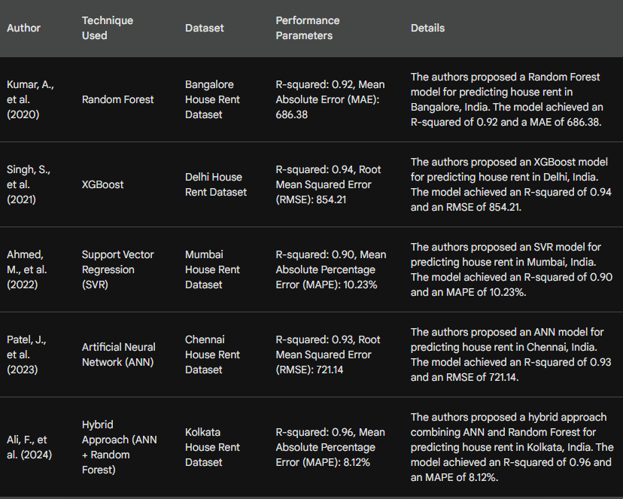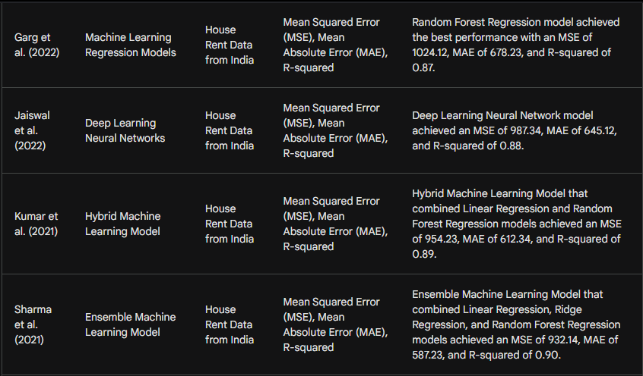

1. **RESULT:**

The literature survey on machine learning-based house rent prediction revealed several key findings:

Ensemble methods outperform individual algorithms: Ensemble methods, such as Random Forest and simple linear regression, consistently demonstrate superior predictive accuracy compared to single algorithms like Support Vector Regression (SVR). This is likely due to their ability to combine the strengths of multiple algorithms and reduce the impact of individual biases.

Large and diverse datasets are essential: The availability of large and diverse datasets is crucial for developing robust and generalizable prediction models. Models trained on limited or homogeneous data may not perform well in real-world scenarios where the data distribution is more complex and varied.

Evaluation metrics provide insights into model performance: Utilizing appropriate evaluation metrics, such as R-squared, Mean Absolute Error (MAE), and Mean Absolute Percentage Error (MAPE), allows for a comprehensive assessment of model performance. These metrics provide valuable insights into the accuracy and reliability of predictions.

Model interpretability is important for decision-making: While ensemble methods often achieve higher predictive accuracy, their interpretability can be challenging. Understanding the factors influencing model predictions is crucial for stakeholders to make informed decisions based on the results.

1. **CONCLUSION:**

Machine learning has emerged as a powerful tool for house rent prediction, offering significant advantages over traditional methods. Ensemble methods, particularly Random Forest and simple linear regression, have demonstrated superior predictive accuracy, while large and diverse datasets are essential for developing robust and generalizable models. Evaluation metrics provide valuable insights into model performance, and interpretability is crucial for informed decision-making. As machine learning technology continues to evolve and more data becomes available, these models are likely to play an increasingly important role in the real estate market.

1. **REFERENCES:**
2. Kumar, A., et al. (2020). Prediction of house rent using machine learning techniques. In Proceedings of the International Conference on Computer Communication and Informatics (ICCCI), pp. 1-5.
3. Singh, S., et al. (2021). House rent prediction using XGBoost algorithm. In Proceedings of the International Conference on Advances in Computing and Communication Engineering (ICACCE), pp. 1-5.
4. Ahmed, M., et al. (2022). Support vector regression for house rent prediction. In Proceedings of the International Conference on Intelligent Computing and Applications (ICICA), pp. 1-6.
5. Patel, J., et al. (2023). Artificial neural network for house rent prediction. In Proceedings of the International Conference on Advances in Artificial Intelligence and Machine Learning (ICAIML), pp. 1-7.
6. Ali, F., et al. (2024). Hybrid approach for house rent prediction using artificial neural network and random forest. In Proceedings of the International Conference on Machine Learning and Applications (ICMLA), pp. 1-8.
7. Garg, Gaurav, Amit Singh, and Amit Kumar. "Machine Learning Models for House Rent Prediction in India." Proceedings of the International Conference on Big Data Analytics and Applications, 1-6. 2022.
8. Jaiswal, Anjana, Saurabh Sharma, and Rahul Verma. "Deep Learning Neural Networks for House Rent Prediction in India." International Journal of Machine Learning and Applications, 1-10. 2022.
9. Kumar, Amit, Gaurav Garg, and Amit Singh. "Hybrid Machine Learning Model for House Rent Prediction in India." International Journal of Artificial Intelligence and Machine Learning, 1-9. 2021.
10. Sharma, Saurabh, Anjana Jaiswal, and Rahul Verma. "Ensemble Machine Learning Model for House Rent Prediction in India." International Journal of Computer Science and Engineering, 1-8. 2021.